Instructions:
- Please complete the form using Capital Letters.
- Completed proposal must be submitted through the assignment drop box

Course: | Bachelor in Science In Business Information Technology
Name of Student: | NGUYEN LAM MINH PHUONG
Email Address: | virgostarinlove@hotmail.com |  | Contact No:
Student ID: | 018800002706
Project Title: | Customers Relationship Management System For  PTS. Fashion Business.
Total Number of Pages including this cover page:
Date of Submission: |  | 12/03/2011

Table of Contents
Background 3
Aim 4
Object 4
Research Approach 5
Research Design 6
Time Line 7
Reference 8

Background

Company PTS is doing fashion business, provided with large scale market in Singapore, the range of customers are from Kids to young adult men and ladies. Base on that, company require the sale number must be always head high and by doing so, company decided to put the business through internet. However, after created website, the sale number could not stable with number of sale in term and season. With that problem, now manager gave number strategy about number of sale, to cover that problem company give with new idea that is new CRM software, this Customers Relationship Management combine with the website will make new hit for number of sale of company.
To Force number of sale increase more than 90% for ever month and season sale. This CRM will provide with full function which could help the business maintain success and grow up number of customers as well. This CRM help business get closer with customers whom are old customers as well the new customers of company, by combined between software and website service those are able to provide to customers an easiest way for shopping online.
CRM software able to locate the database of business and base on that database of company sale list, CRM will calculation and offer royal point to old customers as well as sending new promotion to new customer to aim more customers for company.
This CRM will bring up the profit of company and lower the cost for advertisement to customers and more flexible to business and connection between company and customers. This tool able to support for huge business and able to do automatic sale force which able to check for sale data in month period and giving out the solution for business and bring up the customers to website for shopping.
In various ways between CRM and old way management the business is they are keep track on customers and solve the business problem and bring up the number of sale of company in short period of time as possible. The focus point of this system is to keep connection between customers and company for long time. Provide marketing strategy to customers help business grow up and make abstraction to more customers improve number of products sale and customers in company.

Aim

This CRM to help business to improve the number of sale and also to build the good relationship between company and customers, also provide services such as to help customers know more about business as well as promotion during that period of time. Even system can do management by keeping track on profit data of business and thereby helping the business to grow up more profit in sale to meet up the manager’s requirements.

Object

Online shopping has grown rapidly and has improved the way customers come and shop; there is no more time for shop in store takes over the market and sale data board anymore. Company want to grow and get more customers the best way is hold your past customers and getting new customers from internet. That will need to requirement strategy about marketing and customers service. To success in customers service is the big win for holding customers back with company, so here is 5 strong ideas for Customer Relationship Management to get over current service and get better way for service in future.
Feature of the proposal system
- Keep track on customers for time been customers with company. | Base on this, company will able to offer better promotion for those royal customers and keep connection with them.
- Provide auto sale force by sending discount amount base on number of time customers purchased in the past. | This will help company to control the sale and sending special discount information for customers are new and old customers even though company do not have any sale season in that period.
- Send code discount to customer base on database and send them through email | With the code for special discount so system able to control the term and time for discount when it had been send out.
- Able to support sale strategy for business when sale profit below 90%. | System will help managers have a better control on sale and bring new customers and old customers back to company when time needed.
- Seeking for solution from senior managers when sale strategy did not meet the system requirement during sale period. | Provide to manager with right time and right information about sale market when it is needed so they can give out the new solution can help the company situation.

Research Approach

Every project must have clear goals. The goals of CRM are to get customers come to company and keep the sale number always high before we start the project, we need to determent the critical risk during and after the system build, company need this system can able to support their sale web page, and able to control all the customers data as well as sale data, even have right update for sale items. Leak customer’s information and could not control well sale data combine with the sale items, the system may be bring down the whole company system. At first step, do we need to change and make this CRM for current and what it needs to change so can improve the current situation. To answer that, let look back to current system, it did not do well in connection customers with company together so the new CRM will help company to get over the old Call Center of company, so it will help company service much better.
To doing so, we have to make sure what type of CRM is suitable for company business and the system must to be understanding the customer and how to get closer with customers so company can understand and know what are customers needed. Base on that fact, we have to determent how we collect the customers information also same as what CRM can do.
By going through some research database, we known that all customers information getting from direct sale is 60%, following is through email is 50%, by using call center and website visits is 43% and 40% corresponding. So therefore the system must have function such as Sale force automation so it can support for business and locate all the data from data warehouse. This data warehouse is known as a source for company its self can store all information from every store about their product specification as well as customer orders. This will provide good view about controlling the whole system with function included as billing system, order and provisioning system, point of sale, web servers, marketing data and corporate financial packages. With all this will be able to store under data warehouse ability. To analytical CRM, it must able to communicate with customers and capabilities to provide new business strategies, other hand we can understand this CRM will have only single functions that to use for supporting for business sale, so it must ability to control all the functions below:
- Reward customers with personalization discount
- Proactively offer products and service that fit a given customers needed base on what customers purchase in past.
- Increase number of sale by sending more production information base on customers personalizing profile on website.
- Next sequential purchase product analysis.
- Revenue analysis.

Research Design

To build the success CRM, at first we have to determent the usage and cost to build it, we have to plan out who will using it and capabilities with current system from there we will able to avoid wasting money and time for it.
Customers Relationship Management must be simple and easy to use with friendly users is very important so we do not need to train employee for how to using it. It also able runs on most common flat form in system. However, like what had mention above, the CRM must be friendly users, it must be carry it meaning so we not wasted much time and fund for training our staff to using the system and bring more usable of system more useful.
CRM is most important to bring up the business profit by carry in more customers therefore customers information and marketing data is very importance so the privacy and security system must be able to protect from leaking out and all that data will ensure not to share with any third parties and safe guards are always prevent any illegal access from outside.
This CRM is work link with website which access from internet network so for maintenance is unnecessary for any hardware.

Customers
Company Website
Customers Contact information

Sale information and Promotion data

Products data
Customers Relationship Management system

Senior Managers
Sale Promotion Information

Sale Strategy and Sale information

Figure 1: CRM system mapping

Time Line

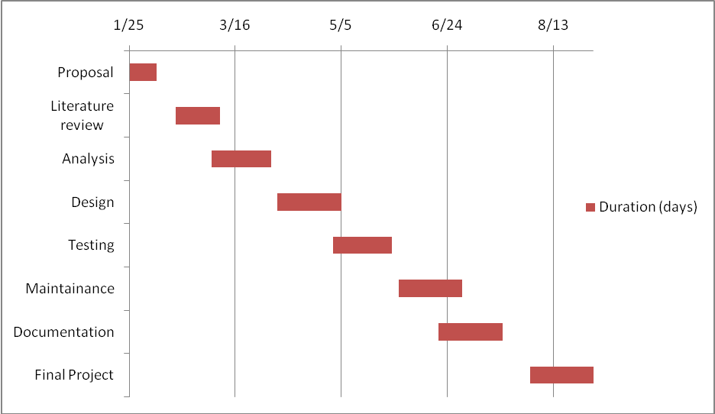

Task
- Project Proposal
- project literature review
- Project Analysis
- Project Design
- Project Testing
- Project Maintenance
- Project Documentation
- Final Report

Reference

The CRM Handbook, Jill Dyche, 8Th Printing July 2005.
http://en.wikipedia.org/wiki/Customer_relationship_management, last access 07/03/2011, From Wikipedia, the free encyclopedia.

